St Michael’s College, Enniskillen

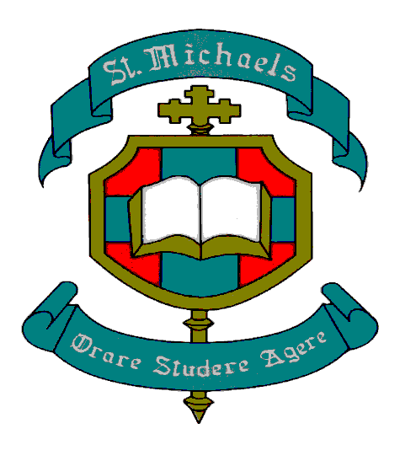

JOB DESCRIPTION

POST OF:

Teacher of Music with General Subjects to GCSE

Temporary (beginning of February to end of June 2026), Full-time

ST MICHAEL’S COLLEGE, ENNISKILLEN
JOB DESCRIPTION

Teacher of Music with General Subjects to GCSE
Temporary (beginning of February to end of June 2026), Full-time

Purpose of Post: Teaching of Music/General Subjects to KS3 and GCSE.

Major Tasks:
- Preparing, planning and teaching Music/General Subjects across a range of abilities at KS3 and KS4.
- Preparing, planning and teaching small groups of pupils to address individual learning needs.
- To liaise with other relevant Department Heads and work collaboratively with others, to support the delivery of Music/General Subjects at KS3 and KS4.
- To use ICT to enhance Learning and Teaching.
- To manage relevant resources under the direction of the Principal and to organise and attend departmental and other meetings as required.
- To monitor and evaluate curriculum innovation and delivery.
- To assess and monitor pupil progress and performance through classwork, homework and examination, and to implement school and statutory assessment, record and report internally and externally.
- To develop and implement a range of strategies and initiatives to raise standards.
- To oversee the differentiated needs of learners across Key Stages.
- To maintain good order and positive behaviour among pupils in accordance with school policies.
- To act as Form Teacher with associated Pastoral Care duties.
- To actively encourage, promote and lead extra-curricular / after-school activities relevant to the Music Department and General Subjects.
- To develop and implement new approaches and initiatives within the Music Department, alongside whole school professional learning.
- To undertake supervisory duties, rotas and other duties as requested by the Principal.
- To act as lead teacher in the area of music up to and including GCSE.

Reporting Relationships
- Report to the relevant Head(s) of Department.
- As Form Teacher, to work with Head of Year.
- To report to the Principal, Senior Leadership Team and External Agencies as required.

Activities:

Preparing/planning/teaching:
- Planning and preparing lessons.
- Teaching, according to educational needs, the pupils assigned to him/her, including the setting and marking of work.
- Teaching of Music/ General Subjects to students in line with the schemes of work and subject specifications as adopted within the department(s).
- Preparation and presentation of lessons of suitable content, level and interest to engage pupils throughout the age range.
- Keeping up to date with developments in the subject(s).
- Attendance at relevant courses to develop skills and knowledge appropriate to the teaching of the subject(s).
- Attendance at meetings as required by the relevant Head(s) of Department and senior leadership team.
- Attendance at (and contribution to) assemblies.

Assessing/recording/reporting:
- Assessing, recording and reporting on the development, progress and attainment of pupils.
- Setting of homework tasks in line with the homework timetable as prescribed by the Principal.
- Marking of pupils’ work. Implementing Assessment for Learning strategies in line with the school’s policy.
- Keeping records of the standard achieved by pupils in their work and using those records and other available data to set targets for pupils.
- Grading of pupils and writing of reports on pupils and to provide next steps to encourage student development and progression.
- Attendance at parents’ evenings and meeting with parents.
- Maintenance of discipline and an atmosphere which is conducive to learning during lessons.
- Promoting the general progress and well-being of the individual class.
- Supervisory duties during break.
- Playing a part in the extra‐curricular life of the school.

Other:
- To be aware of the School’s policy on Child Protection.
- To assist at school functions and with extra‐curricular activities.
- Attendance at Open Evening events to supervise pupils performing practical work and to speak to parents and prospective pupils.
- To carry out all teaching responsibilities as assigned.
- To perform such other duties as may be required by the Principal.

NB: The above is an exemplar of the MAJOR TASKS and ACTIVITIES of the post. It is not intended as an exhaustive list of every one of the postholder’s duties. The full Professional duties of the post are as set out in Schedule 3 of the Teachers’ (Terms
and Conditions of Employment) Regulations (NI) 1987.

January 2026

